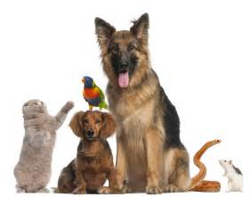
HANDY TIPS ON KEEPING PETS
Newydd recognises the benefits keeping pets can bring, so here are some handy tips on how to keep your pets safe and in good health whilst fulfilling their welfare requirements. keeping a pet should be a positive experience for you and others.
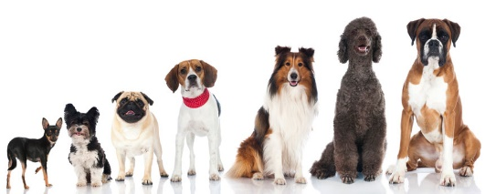  DOGS | 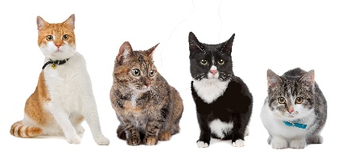  CATS
A dog is fully dependent on its owner and the law is very clear and says that owners must take reasonable steps to ensure that your dog: | Although cats can be fairly independent, every owner has a responsibility for its welfare, the law is very clear and says that owners must take reasonable steps to ensure that your cat:
Has a suitable environment to live in – dogs need space to walk around and play but for sleeping/ resting you will need to provide a dry, draught free resting area which is large enough to allow them to lie flat on their side. | Has a suitable environment to live in –although cats like to roam they require a safe domestic area to play. For sleeping/resting you will need to provide a dry, draught free area.
Has a healthy diet – your dog must have access to fresh clean water at all times. It is advised that dogs be fed twice daily but at least once a daily. It is important that you know the dietary requirements of your dog and a vet is the best person to advise you about the care of your dog. | Had a healthy diet – a dog must have access to fresh clean water at all times. It is advised that cats be fed at least once a day. It is important that you know the dietary requirements of your dog and a vet is the best person to advise you about the care of your cat.
Is able to behave normally – training a dog can take time and effort but the rewards will far outweigh the time you put in. It is important to reward good behaviour. Exercise is an important part of owning a dog and keeps your dog, and you, physically fit. Exercise also increases stimulation for your dog through interaction with other people, animals and smells. If it likely that during exercise. Your dog will want to toilet so it is important to remember to take equipment clean up your dog’s mess and dispose of it hygienically. | Is able to behave normally – hunting is natural behaviour for cats as well as scratching and clawing - these natural instincts can be met by providing appropriate toys for play. Exercise is important and you should make sure your cat has exercise opportunities to keep them active- especially important for indoor cats.
Has appropriate company – Dogs are very sociable animals and need to be around people, other dogs and animals. They also require other stimulants such as suitable toys. Without sufficient company a dog can suffer from separation related behaviour which can include constant barking when left alone – this noise can cause a nuisance and upset neighbours. Dogs should not be left on their own for more than a few hours each day. | Has appropriate company – It is important that you get to know your cat to see if they like being around other people, cats or animals, As a cat owner you should make sure that you cat is handled properly by other people/children.
You also need to ensure that your dog/cat is protected from pain, suffering, injury and disease – you will regularly need to check the health of your dog/cat. Every dog/cat is different and as you get to know your pet you will understand when it is not its usual self. You need to ensure that all injuries and illnesses are treated promptly by a vet. Routine health care is important including vaccination and flea/worm control.

Neutering is important to keep the animal health and prevent unwanted animals. Some charities provide subsidised neutering services for low income households and advise on neutering can be sought from a vet or animal charity such as the RSPCA.

MOST COMMON DOG ISSUES | MOST COMMON CAT ISSUES
Dog fouling – it is an offence not to clean up dog fouling under the Clean Neighbourhoods and Environment Act 2005, Dog fouling not only looks unpleasant but more importantly there are health implications associated with dog faeces. Please clean up after your dog straight away by removing and disposing of faeces appropriately. | Cat Fouling – although it is not an offence not to clean up after your car, cat fouling is just as unpleasant as dog fouling and carries the same health implications. Although it is unlikely that cats will foul in public areas, they do foul in private gardens. We encourage all tenants who have cats as pets to provide sufficient litter trays to encourage responsible toileting and regularly clean them e.g. twice a day.
Noise - the most common noise nuisance is persistent dog barking but other noises may include scratching and banging noises. It a dog has sufficient company and stimulation it is unlikely to cause excessive noise. Please ensure that your dog does not cause a nuisance, harassment or annoyance to people living near you. All reports of alleged dog nuisance will be investigated and we will work closely with the owner to provide and advice and support on how to stop the nuisance in line with our ASB procedure. However, ultimately if the nuisance does not stop we can withdraw permission to keep a dog either with the tenant’s compliance or through the courts. | Roaming – By their nature, cats love to roam which can contribute to fouling, Neutering your cat reduces the problem of roaming, It is also important to register your car using methods such as microchipping or tattooing so that it they do stray they can be returned to you.
Damage to Property – if a dog is cared for properly (well trained, exercised and has sufficient company) then it is unlikely the pet will damage your property. If damage does occur due to your pet, then you are responsible for either making good the damage yourself or paying us to carry out the work on your behalf. | Damage to Property – if a cat is cared for properly (exercised and has sufficient company) then it is unlikely the pet will damage your property. Cats love to scratch and if they are not provided with equipment to allow them to do this, then it is likely that they will use your property. If damage does occur due to your pet, then you are responsible for either making good the damage yourself or paying us to carry out the work on your behalf.
Uncontrolled dogs – Dogs are left to roam communal areas/gardens/play areas. Please ensure that your dog is controlled and kept on a short lead whenever you are outside your home and that your dog has wears a collar displaying your name and address when it is in a public place.

MICROCHIPPING
From April 2016, it became compulsory for all dogs in England and Wales to be microchipped. A microchip is a tiny device that is implanted under the skin normally between the shoulder blades. Each microchip carries a unique 15-digit number that can only be read by a special reader. The number is linked to an entry on a database that stores the animal’s information plus the details of their keeper. If your pet is lost or stolen, this is the best way of tracing them. To get your dog microchipped visit your local vet, vet nurse or anyone else who has been specially trained. Please note that if your dog is picked up by the local authority without a chip and you fail to get them chipped within 21 days, this could result in a criminal record and a £500 fine!
BIRDS
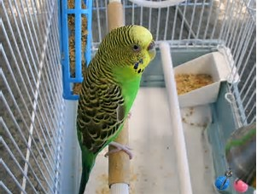
It is illegal to keep a bird in a cage in which it cannot fully stretch its wings in every direction. Where more than one bird is kept in one enclosure it is essential that there is enough space for all the birds to perch at the same time. Most birds are relatively intelligent and active social animals so need a lot of environmental enrichment including the ability to fly. This may be provided by an aviary or free flight within the house (this can raise health issues as birds defecate when walking or flying not at a regular time/location). Environments (cages) can be enriched with toys and mirrors etc. Some species of parrot also make a lot of noise and this can cause nuisance. Further advice on keeping specific types of birds can be obtained from specialist groups and specialist vets who can be located either by contacting your local vet or the British Small Animal Vetinary Association (see useful contacts for website and phone number).
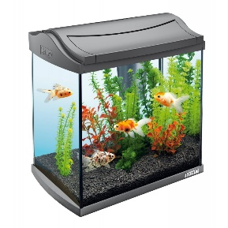
FISH
Even the smallest aquarium should contain no less than 30-40 litres of water (this is relatively heavy as 1 litre weighs approx. 1kg) so make sure you speak to Newydd before buying a large tank. For further information on the keeping of fish, contact OATA (see useful contacts).

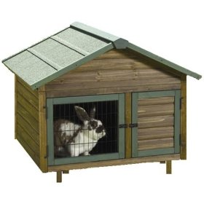
RABBITS
Rabbits are highly social animals that require careful feeding and care to live a full and healthy life – they are not as cheap and easy to maintain as people think. Neutering is recommended to prevent inadvertent breeding and fighting. There are two main ways to keep rabbits properly. First they may live in small neutered groups in a weatherproof hutch secure from predators with an exercise area. The hutch must be tall enough for the adult rabbit to sit up on its hind legs, stretch out full length or perform three consecutive hops (at least 1.8m/0.9m x 0.76m in size). Where more than one animal is kept together, sufficient space must be available for them all to perform these activities at the same tie once they have reached adult size.
The exercise area should be as large as possible and allow the rabbit to run as opposed to hop. Putting it on a paved area will make it easier to clean and prevent the rabbit from digging. A permanent or movable run may also be sited on grass to enable the rabbit to graze. It is essential to provide a secure lid, shade and bolt holes and the owner must be able to dispose of soiled bedding (in the bin or by composting it).
Secondly, rabbit can be kept as house pets. They can be easily trained to use a litter tray and can have free run in the home. It is acceptable to have just one rabbit in situations where they will enjoy a lot of contact with humans but it is preferable to have a second rabbit to keep them company. Rabbits are however prone to chew inanimate objects to control tooth growth, electric cables are therefore a significant risk and fixtures and fittings will also need some protection. Further info on keeping rabbit can be obtained from the Rabbit Welfare Association (see useful contacts).
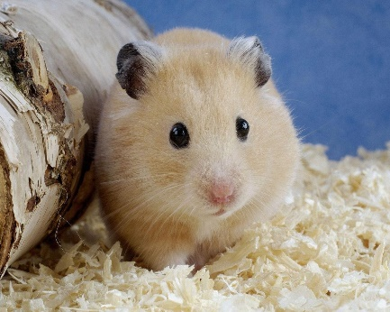
DOMESTIC RODENTS – HAMSTER, MICE, GERBILS, RATS AND GUINEA PIGS
Domestic rodents can be kept indoors space permitting, although guinea pigs are best kept outdoors. They do not need much living space but their accommodation should be the right size for the species and numbers kept. The animals need to have appropriate outlets for physical and mental stimulation such as digging and nest building. A running wheel alone is not enough. The accommodation should also be well maintained and always hygienic. Some species should be kept on their own and others as a pair. Where a pair of animals is kept, the owner should determine the sex of each animal when they are bought in order to prevent fighting and unwanted litters.
 | Minimum Cage area (length x width x height)
Individual hamster | 75 x 40 x 40 | Individual (Syrian)  Pair – same sex (Russian)
Pair of mice | 75 x 40 x 40 | Pair - same sex
Pair of gerbils | 90 x 37.5 x 37.5 | Pair – same sex
Individual rat | 90 x 60 x 150 | Pair – same sex
Individual guinea pig | 120 x 60 x 60 | Pair - same sex

REPTILES (TORTOISES, TERRAPINS, SNAKES, LIZARDS ETC.) & SPIDERS
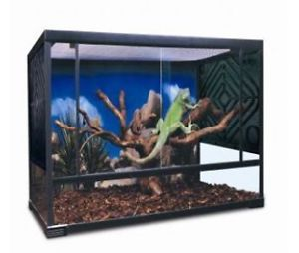
Reptiles, amphibians and invertebrates can provide a fascinating hobby and companionship. If cared for well, many of these species can live a long time (up to 15 years or more for some species of spiders and lizards). This group includes a wide variety of species each with their own needs. In general, the environment in which any animal is kept should be designed and constructed by someone with knowledge of their behaviour. Many exotic animals (iguana, lizards, snakes, terrapins, snails and spiders) naturally carry bacteria and diseases transmissible and harmful to man e.g. salmonella, cryptosporidium, e.coli 157, campylobacter and meningitis. Care sheet provided by pet suppliers may give advice on this issue but advice should also be sought from a vet or local environmental health department to find out whether you should carry out test on the animal in order to protect yourself, your family and friends. Even if test results are negative, owners should always wash their hands after handling such animals, either using hot water and soap or a suitable alcohol gel. Please make sure you learn about your exotic animal (what size they grow to, do you have enough space for them, what temperature/humidity doo they need, what do they eat and how do you plan to feed it properly - as many owners do not know enough so cannot care for them properly and as a result they live only a few months. Please contact the British Small Animal Vetinary Association for more information (see useful contacts).
FINALLY – Remember, when you are away from home – you will need to make arrangements for a responsible person to care for your pet in your absence – this person should attend to your pet every day!
USEFUL CONTACTS
FOR DOGS

Dog’s Trust | A dog welfare charity providing advice on all aspects of dog ownership | www.dogstrst.org.uk  020 7837 0006
The Kennel Club | Website for dog owners and those with working dogs | www.thekennelclub.org.uk
Association of Pet Dog Trainers |  | www.apdt.co.uk  01285 81811
The Good Dog Campaign |  | www.gooddogcampaign.co.uk  01664 411111
Home Rescue | Deals with the rehoming of unwanted dogs | www.giveusahome.co.uk

FOR CATS

Cats Protection | A charity that provides advice on cat car, runs a rescue service and a service to find new homes for cats. It may provide financial assistance for neutering cats. | www.cats.org.uk  08702 099099
Feline Advisory Bureau |  | www.fabcats.org
Cat Rehoming Centre (Catchat) | A charity homing service for unwanted abandoned cats | www/catchat.org/wales

FOR BIRDS

National Council for Aviculture |  | 01782 305042

FOR FISH

Ornamental Aquatic Trace Association (OATA) |  | www.ornamentalfish.org

FOR RABBITS

Rabbit Welfare Association |  | www.rabbitwelfare.co.uk

GENERAL

RSPCA | A charity that investigates complaints of cruelty and neglect. They run animal hospitals and clinic for low income household and have centres that house animals looking for new homes. They provide animal care and welfare advice and may provide financial assistance with neutering animals | www.rspca.org.uk  0870 33359999 (general)  0870 5555 999 (24 hour national cruelty and advice line)
PDSA (Peoples Dispensary for Sick Animals) | A charity that runs animal clinics to provide Vetinary care for sick animals owned by low income households | www.pdsa.org  01952 290999
The Pet Health Council |  | www.pethealthcouncil.co.uk  020 73796545
Pet Care Trust |  | www.petcare.org.uk
Petlog | Online database for lost and found microchipped pets | www.petlog.co.uk
The Royal College of Vetinary Surgeons website | Had a find a vet facility | www.rcvs.org.uk
Home Sitters | A home sitting service to care for your pet (and home) when you are away | www.homesitters.co.uk
British Small Animal Vetinary Association |  | www.bsava.com  01452 726700

